|  |
| --- |
| Aufgabe Reflow Ofen |
|  |

|  |  |  |  |
| --- | --- | --- | --- |
| Version | Änderung | Name | Datum |
| 1.0 | Erstellung | Kenneth Mathis | 7. Oktober 2019 |

Inhalt

1 Aufgabenstellung 3

2 Hardware-Struktur 3

2.1 Systembeschreibung 3

2.1.1 Beschaltung der Hardware 3

2.1.2 Inputs 4

2.1.3 Outputs 4

2.1.4 Steuersignale & LED Positionen 4

3 Software-Analyse 5

3.1 Struktogramm zum Hauptprogramm 5

3.2 Struktogramm zur Flankenerkennung 5

3.3 Ramp Heat 6

3.4 Heat Up 6

3.5 Ramp Reflow 7

3.6 Reflow 7

3.7 Cooldown 8

4 Source-Code 8

4.1 Hauptprogramm 8

4.2 Matrix Lib 12

4.2.1 matrix.h 12

4.2.2 matrix.c 12

4.3 7Segment Lib 13

4.3.1 sevenSegDisp.h 13

4.3.2 sevenSegDisp.c 13

4.4 ADC Lib 15

4.4.1 adc.h 15

4.4.2 adc.c 16

4.5 Convert Lib 17

4.6 Flankenerkennung Lib 18

4.6.1 edge.h 18

4.6.2 edge.c 18

4.7 RGB Lib 19

4.7.1 RGB.h 19

4.7.2 RGB.c 19

5 Testprotokoll 20

5.1 Testablauf 20

5.2 Testbericht mit Fazit und Massnahmen 21

# Aufgabenstellung

Es soll ein Programm zur Steuerung eines Reflow-Ofens erstellt werden.

* ***Weitere Details sind der Original-Aufgabenstellung zu entnehmen!***

# Hardware-Struktur

## Systembeschreibung

Es wird das ZLV-MINT Entwicklungs Board mit dem Mikrocontroller Atmel ATmega2560 verwendet, welches für die Programmierung sowie das Debugging mit dem Atmel-ICE-Debugger betrieben wird (per JTAG Schnittstelle).

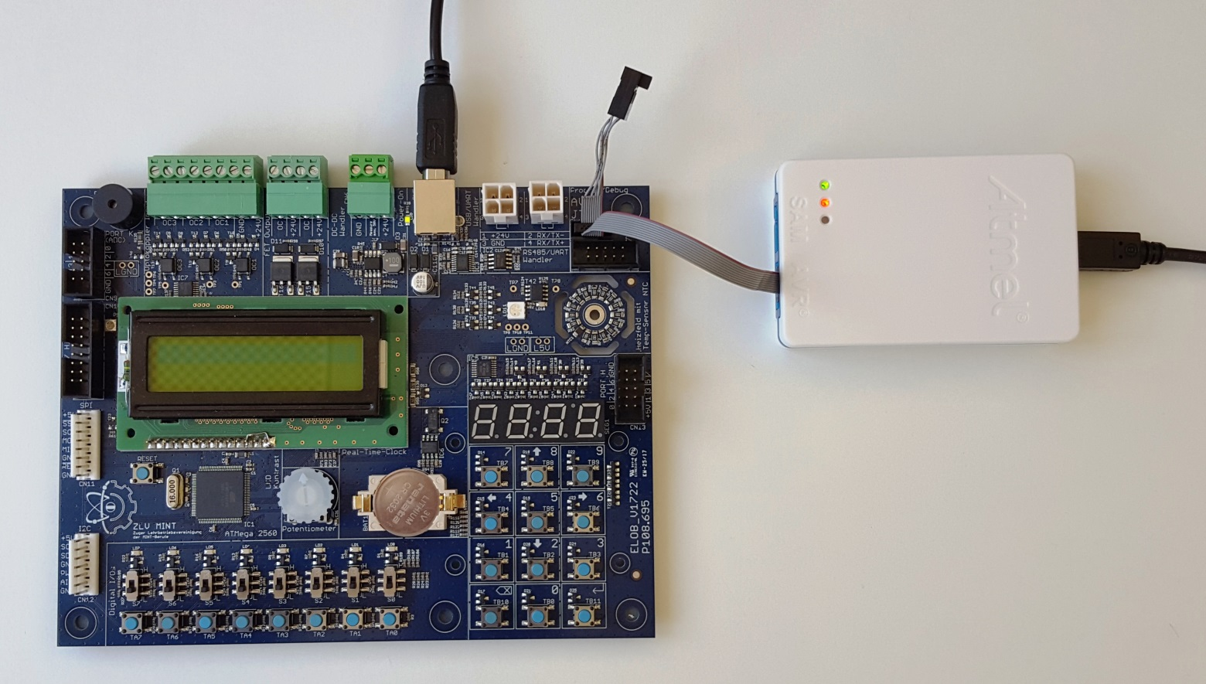

### Beschaltung der Hardware

Die Ports für Taster, Schalter, LEDs und weitere Module sind direkt und fix auf dem Board verbunden.  
Bestimmte weitere Peripherie kann extern über entsprechende Anschlussleisten oder Stecker/Buchsen angeschlossen werden.

**Logik für Taster, Schalter und LEDs**

Taster 1 = gedrückt 0 = nicht gedrückt

Schalter 1 = Schalterposition oben 0 = Schalterposition unten

LED 1 = leuchtet 0 = dunkel

### Inputs

|  |  |  |  |  |
| --- | --- | --- | --- | --- |
| **Bezeichner** | **uC-Pin** | **Bauteil** | **Logikpegel-Definitionen** | **Grobe Funktionsbeschreibung** |
| startTaster | PJ0 | TA0 | 1 = Gedrückt | Taster für Betriebsstart |
| stopTaster | PJ1 | TA1 | 1 = Gedrückt | Taster Stop |

### Outputs

|  |  |  |  |  |
| --- | --- | --- | --- | --- |
| **Bezeichner** | **uC-Pin** | **Bauteil** | **Logikpegel-Definitionen** | **Grobe Funktionsbeschreibung** |
| ledRed | PB5 | LD11 | 1 = Leuchtet | Rote RGB-LED |
| ledGreen | PB6 | Grüne RGB-LED |
| ledBlue | PB7 | Blaue RGB-LED |
| enSevenSeg | PG2 | IC5A | 1 = Enabled | 7-Segment Enable Signal |
| segSel1 | PG0 | Siehe Tabelle | 7-Segment Select Signal |
| segSel2 | PG1 |
| segA | PH0 | SEG1 | 1 = Leuchtet | 7-Segment LED Signal (Siehe Schema) |
| segB | PH1 |
| segC | PH2 |
| segD | PH3 |
| segE | PH4 |
| segF | PH5 |
| segG | PH6 |
| segDP | PH7 |
| heatPad | PB4 | Rhpd | 1 = Heizt | Widerstände des Heizfeldes |

### Steuersignale & LED Positionen

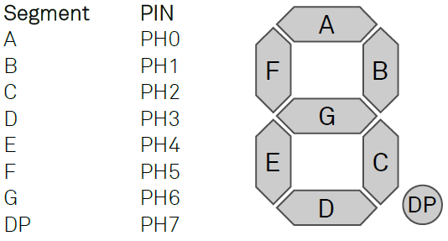

|  |  |  |
| --- | --- | --- |
| **PG1** | **PG0** | **Segment** |
| 0 | 0 | 00:0**0** |
| 0 | 1 | 00:**0**0 |
| 1 | 0 | 0**0**:00 |
| 1 | 1 | **0**0:00 |

# Software-Analyse

## Struktogramm zum Hauptprogramm

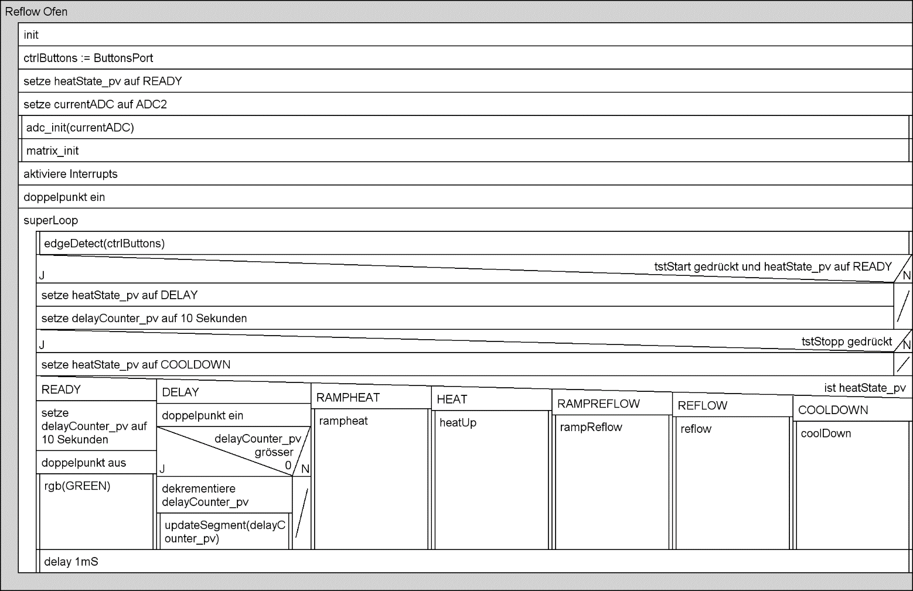

## Struktogramm zur Flankenerkennung

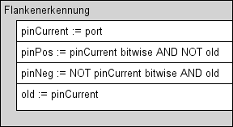

## Ramp Heat

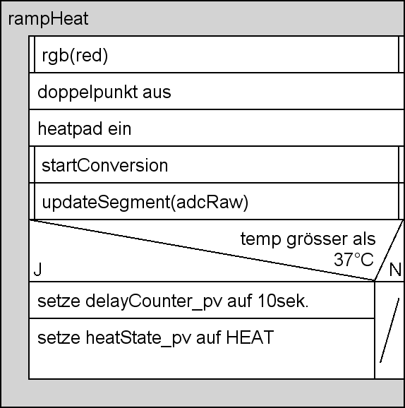

## Heat Up

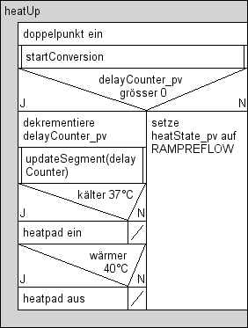

## Ramp Reflow

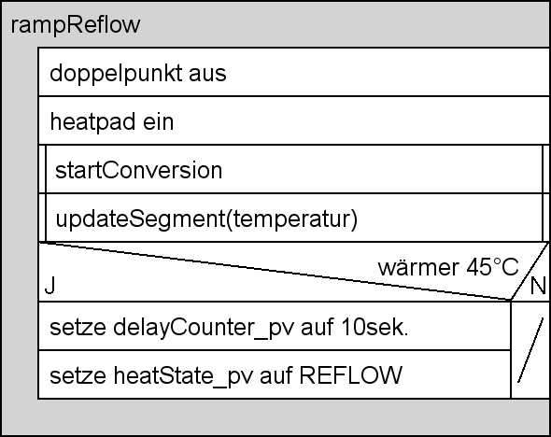

## Reflow

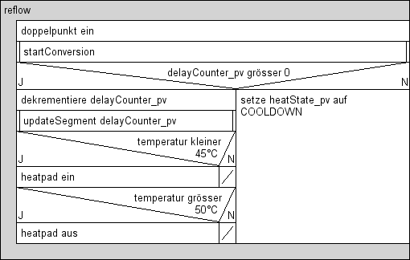

## Cooldown

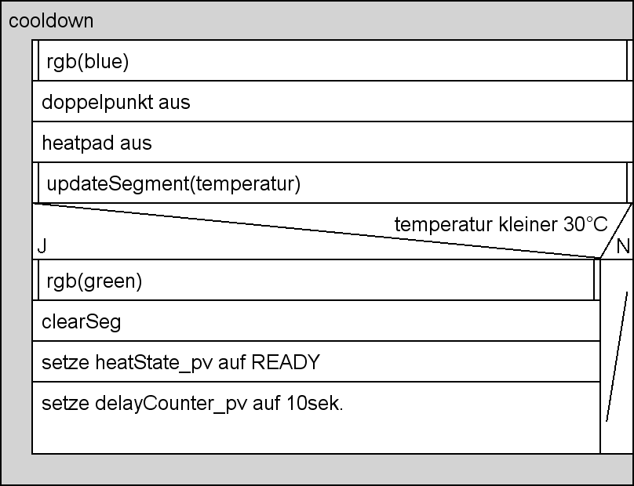

# Source-Code

## Hauptprogramm

/**

* @file main.c

* @author Kenneth Mathis

* @version 1.0

* @brief Program for simulating a reflow oven's workflow

*

* ******************************

* Date Vers. Name Comment/Change

* 17.09.19 1.0 Kenneth Mathis Created

*/

//***INCLUDES***

#define *F_CPU* 16000000UL

#include <avr/io.h>

#include <util/delay.h>

#include <avr/interrupt.h>

#include "matrix.h"

#include "sevenSegDisp.h"

#include "adc.h"

#include "convert.h"

#include "edge.h"

#include "RGB.h"

//***DEFINES***

//**Control Buttons**

#define tstStart_pos (ctrlButtons.pinPos & (1<<0))

#define tstStop_pos (ctrlButtons.pinPos & (1<<1))

//**Heatpad**

#define heatPad_on (PORTB |= (1<<4))

#define heatPad_off (PORTB &= ~(1<<4))

//***GLOBAL VARIABLES***

adc_t currentADC;

enum heatingStates {READY, DELAY, RAMPHEAT, HEAT, RAMPREFLOW, REFLOW, COOLDOWN};

enum heatingStates heatState_pv;

*uint16_t* delayCounter_pv;

//**Predefined Colours**

const color red = {1,0,0};

const color green = {0,1,0};

const color blue = {0,0,1};

//***PROTOTYPES***

void rampHeat(void);

void heatUp(void);

void rampReflow(void);

void reflow(void);

void coolDown(void);

/**

* @brief Main routine, this is where the magic happens.

* @param void

*/

int main(void){

//**VARIABLES**

edge ctrlButtons = {0,0,&PINJ}; //Struct for edge detection

heatState_pv = READY; //Variable to store the current process state

//**Init**

currentADC.usingADC = ADC2;

adc_init(&currentADC);

matrix_init();

sei();

colon_on;

//**Data Direction Registers**

DDRB = 0x10; //Set the 4th bit for the heatpad to output

//***SUPER LOOP***

while (1){

//**Control button detection**

edgeDetect(&ctrlButtons);

if(tstStart_pos && heatState_pv == READY){

heatState_pv = DELAY;

delayCounter_pv = 10000; //Set a 10s Countdown

}

if(tstStop_pos){

heatState_pv = COOLDOWN;

}

getValue(&currentADC);

currentADC.adcReal = toTemeperature(currentADC.adcRaw);

switch(heatState_pv){

case READY:

delayCounter_pv = 10000; //Use a 10s delay on startup if the heatpad has cooled

colon_off;

rgb(green);

break;

case DELAY: //Countdown from 10s

colon_on;

if(delayCounter_pv > 0){

delayCounter_pv--;

updateSegment((*uint16_t*)(delayCounter_pv/10), 4); //Update every 10mS with no Dot

}

else heatState_pv = RAMPHEAT;

break;

case RAMPHEAT:

rampHeat();

break;

case HEAT:

heatUp();

break;

case RAMPREFLOW:

rampReflow();

break;

case REFLOW:

reflow();

break;

case COOLDOWN:

coolDown();

break;

default:

break;

}

//***GLOBAL DELAY***

*_delay_ms*(1);

}

}

/**

* @brief Pre-Heat the reflow oven

* @param void

*/

void rampHeat(void){

rgb(red);

colon_off;

heatPad_on;

updateSegment(((*uint16_t*)(currentADC.adcReal*100)), 2); //Update every 10mS with 2 segment Dotted

//Temperature over 35°C go to the the heating phase

if(currentADC.adcReal >= 37.0){

delayCounter_pv = 10000; //Use a 10s heating period

heatState_pv = HEAT;

}

}

/**

* @brief Heat the PCB

* @param void

*/

void heatUp(void){

colon_on;

if(delayCounter_pv > 0){

delayCounter_pv--;

updateSegment((*uint16_t*)(delayCounter_pv/10), 4); //Update every 10mS with no Dot

//Temperature holding state

if(currentADC.adcReal <= 37.0) heatPad_on;

if(currentADC.adcReal > 40.0) heatPad_off;

}

else heatState_pv = RAMPREFLOW;

}

/**

* @brief Ramp up to reflow temperature

* @param void

*/

void rampReflow(void){

colon_off;

heatPad_on;

updateSegment((*uint16_t*)(currentADC.adcReal*100), 2);

if(currentADC.adcReal >= 45.0){

delayCounter_pv = 10000; //Use a 10s reflow period

heatState_pv = REFLOW;

}

}

/**

* @brief Reflow dat board

* @param void

*/

void reflow(void){

colon_on;

if(delayCounter_pv > 0){

delayCounter_pv--;

updateSegment((*uint16_t*)(delayCounter_pv/10), 4); //Update every 10mS with no Dot

//Temperature holding state

if(currentADC.adcReal < 45.0) heatPad_on;

}

else heatState_pv = COOLDOWN;

}

/**

* @brief Cool down everything

* @param void

*/

void coolDown(void){

rgb(blue);

colon_off;

heatPad_off;

static *uint16_t* adcClearOffset; //ADC reads garbage after reflow part, this counteracts the problem

updateSegment((*uint16_t*)(currentADC.adcReal*100), 2);

if(currentADC.adcReal >= 30.0

|| adcClearOffset <= 10000){ //Is true for 10s to counteract adc garbage.

adcClearOffset++;

}

else{

rgb(green);

clearSeg;

heatState_pv = READY;

delayCounter_pv = 10000; //Use a 10s delay on startup if the heatpad has cooled

}

}

//***INTERRUPTS***

/**

* @brief Interrupt for ADC-Conversion complete

* @param void

*/

ISR(ADC_vect){

currentADC.adcRaw = ADC;

}

## Matrix Lib

### matrix.h

/**

* @file matrix.h

* @brief LIB to control the mux and enable signal to the seven segment display and keypad.

* @author Kenneth Mathis

* @version 1.0

*

* ******************************

* Date Vers. Name Comment/Change

* 09.09.19 1.0 Kenneth Mathis Created

*/

#ifndef MATRIX_H

#define MATRIX_H

//Enable and Disable the segment and keypad

#define mtxEnable (PORTG |= (1<<2))

#define mtxDisable (PORTG &= ~(1<<2))

//Mux signals for selecting a segment/keypad row

#define segSel0_off (PORTG &= ~(1<<0))

#define segSel1_off (PORTG &= ~(1<<1))

#define segSel0_on (PORTG |= (1<<0))

#define segSel1_on (PORTG |= (1<<1))

//***PROTOTYPES***

/**

* @brief Preps the seven segment display and keypad for use.

* @param Void

*/

void matrix_init(void);

#endif

### matrix.c

/**

* @file matrix.c

* @brief LIB to control the mux and enable signal to the seven segment display and keypad.

* @author Kenneth Mathis

* @version 1.0

*

* ******************************

* Date Vers. Name Comment/Change

* 09.09.19 1.0 Kenneth Mathis Created

*/

#include <avr/io.h>

#include "matrix.h"

void matrix_init(void){

//**Data Direction Registers**

//*1=Output*

DDRH = 0xff; //DDR of the individual segments

DDRG |= 0x1f; //DDR of the multiplexing/control signals

DDRD &= 0x70; //DDR of the keypad read pins

mtxEnable; //Enable the matrix

}

## 7Segment Lib

### sevenSegDisp.h

/**

* @file sevenSegDisp.h

* @brief LIB to control the seven segment display.

* @author Kenneth Mathis

* @version 1.0

*

* ******************************

* Date Vers. Name Comment/Change

* 09.09.19 1.0 Kenneth Mathis Created

* 24.09.19 1.1 Kenneth Mathis Added clearSeg

*/

#ifndef SEVENSEGDISP_H

#define SEVENSEGDISP_H

#define colon_on (PORTG |= (1<<4))

#define colon_off (PORTG &= ~(1<<4))

#define apostrophe_on (PORTG |= (1<<3))

#define apostrophe_off (PORTG &= ~(1<<3))

#define segEnable (PORTG |= (1<<2))

#define segDisable (PORTG &= ~(1<<2))

#define clearSeg (PORTH = 0)

/**

* @brief Update the seven segment display with a number

* Note: This function takes care of the incremeting

* so no individual segment can be set.

* @param segNumber The Number to display on the segment.

* @param dotPos The position of the dot. Set it to 4 or higher for no dot.

*/

void updateSegment(unsigned int segNumber, *uint8_t* dotPos);

#endif

### sevenSegDisp.c

/**

* @file sevenSegDisp.c

* @brief LIB to control the seven segment display.

* @author Kenneth Mathis

* @version 1.0

*

* ******************************

* Date Vers. Name Comment/Change

* 09.09.19 1.0 Kenneth Mathis Created

*/

//***INCLUDES***

#include <avr/io.h>

#include <math.h>

#include "sevenSegDisp.h"

#include "matrix.h"

//***DEFINES***

#define setSeg(bit) (PORTH |= (bit))

#define delSeg(bit) (PORTH &= (bit))

//***PROTOTYPES***

*uint8_t* numberToBitmask(*uint8_t* num, *uint8_t* dotted);

void updateSegment(unsigned int segNumber, *uint8_t* dotPos){

static *uint8_t* segPos;

segDisable;

//**Select which segment is currently being displayed**

switch(segPos){

case 0:

segSel0_off;

segSel1_off;

break;

case 1:

segSel0_on;

segSel1_off;

break;

case 2:

segSel0_off;

segSel1_on;

break;

case 3:

segSel0_on;

segSel1_on;

break;

default:

segSel0_off;

segSel1_off;

break;

}

//**Create the bitmask for the given number and set the PORT to it**

*uint8_t* bitmask;

if(segNumber == 0){

bitmask = numberToBitmask(0, 0);

} //If the given number is zero, display it as such

else{

*uint8_t* segDigit;

segDigit = ((*uint8_t*)(segNumber/*pow*(10, segPos)))%10; //Get the digit at segPos from segNumber

if(dotPos == segPos) //Determine if the current segment is dotted

bitmask = numberToBitmask(segDigit, 1);

else bitmask = numberToBitmask(segDigit, 0);

}

setSeg(bitmask);

delSeg(bitmask);

segEnable;

if(segPos < 3) segPos++; //increment the segment position till the last segment

else segPos = 0; //set the segment position to zero if its past the last one

}

/***NUMBER TO BITMASK***

* @brief Turns a number into a seven segment bitmask

* @param: num the number to turn into a 7-segment bitmask

* @param: dotted If the wanted number should be dotted

* @return: the bitmask of the given number

*/

*uint8_t* numberToBitmask(*uint8_t* num, *uint8_t* dotted){

switch(num){

case 0:

return 0b00111111 | dotted<<7;

case 1:

return 0b00000110 | dotted<<7;

case 2:

return 0b01011011 | dotted<<7;

case 3:

return 0b01001111 | dotted<<7;

case 4:

return 0b01100110 | dotted<<7;

case 5:

return 0b01101101 | dotted<<7;

case 6:

return 0b01111101 | dotted<<7;

case 7:

return 0b00000111 | dotted<<7;

case 8:

return 0b01111111 | dotted<<7;

case 9:

return 0b01101111 | dotted<<7;

default:

return 0b01000000 | dotted<<7;

}

}

## ADC Lib

### adc.h

/**

* @file adc.h

* @brief LIB to control the ADC on the ZLV-Mint Board

* @author Kenneth Mathis

* @version 1.1

*

* *******************************

* Date Vers. Name Comment/Change

* 09.09.19 1.0 Kenneth Mathis Created

* 17.09.19 1.1 Kenneth Mathis Added interrupts

*

*/

//***FILE GUARD***

#ifndef ADC_H

#define ADC_H

//A list of all the single ended input ADC's and their mux "id"

enum tblADC {ADC0=0,ADC1,ADC2,ADC3,ADC4,ADC5,ADC6,ADC7,ADC8=32,ADC9,ADC10,ADC11,ADC12,ADC13,ADC14,ADC15};

//A struct for storing all the adc revlevant data

typedef struct{

enum tblADC usingADC;

*uint16_t* adcRaw;

*uint8_t* isLeftAdjusted;

*uint8_t* is8BitMode;

} adc_t;

//***PROTOTYPES***

/**

* @brief Initializes the ADC for use and defines the wanted MUX config.

* @param theADC An adc_t stcut is used to determine all the init values.

*/

void adc_init(adc_t *theADC);

/**

* @brief Start the conversion when an interrupt is used

* @param Void

*/

void startConversion(void);

/**

* @brief Reads the current value on the ADC value and stores its via "reference".

* @param theADC adc_t struct for storing the adcRaw into.

*/

void getValue(adc_t *theADC);

#endif

### adc.c

/**

* @file adc.c

* @brief LIB to control the ADC on the ZLV-Mint Board

* @author Kenneth Mathis

* @version 1.0

*

* *******************************

* Date Vers. Name Comment/Change

* 09.09.19 1.0 Kenneth Mathis Created

* 17.09.19 1.1 Kenneth Mathis Added interrupts

*

*/

//***INCLUDES***

#include <avr/io.h>

#include "adc.h"

void adc_init(adc_t *theADC){

ADCSRA |= (1<<7); //Enable ADC

ADCSRA |= (1<<3); //Enable ADC conversion complete interrupts

if(theADC->isLeftAdjusted || theADC->is8BitMode) ADMUX |= (1<<5); //Produce left adjusted result (8-Bit Mode)

ADMUX |= (theADC->usingADC & 0x1f); //Set the mux to the right DAC, Note: The mux Bits are in two Registers!

ADCSRB |= ((theADC->usingADC>>1) & 0x08);

}

void startConversion(void){

ADCSRA |= (1<<6); //Start the adc conversion

}

void getValue(adc_t *theADC){

ADCSRA |= (1<<6); //Start the adc conversion

while(!(ADCSRA & 0x10)); //Wait till the conversion has ended

if(theADC->is8BitMode) theADC->adcRaw = ADCH; //Return an 8-Bit value if wanted

else theADC->adcRaw = ADC;

}

## Convert Lib

/**

* @file convert.c

* @brief LIB to covert raw ADC values to more useful stuff

* @author Kenneth Mathis

* @version 1.0

*

* *******************************

* Date Vers. Name Comment/Change

* 17.09.19 1.0 Kenneth Mathis Created

*

*/

//***INCLUDES***

#include "convert.h"

//***FUNCTIONS***

float toTemeperatuere(*uint16_t* adcValue){

//Linear Temperature conversion

//float temp;

//temp = (26.32*toVoltage(adcValue))-40.8;

//Conversion via Simplified Steinhart-Hart B-Parameter Equation

//See: https://learn.adafruit.com/thermistor/using-a-thermistor

float steinhart;

steinhart = (toResistance(adcValue))/10000.0; // (R/Ro)

steinhart = *log*(steinhart); // ln(R/Ro)

steinhart /= 3510; // 1/B * ln(R/Ro)

steinhart += 1.0 / (25.0 + 273.15); // + (1/To)

steinhart = 1.0 / steinhart; // Invert

steinhart -= 273.15; // convert to C

return steinhart;

}

float toVoltage(*uint16_t* adcValue){

float volt;

volt = adcValue*0.0048875; //voltage = adcVal*(5V/1023)

return volt;

}

float toResistance(*uint16_t* adcValue){

float resistance;

resistance = (50000.0/toVoltage(adcValue))-10000; //resistance = (Vcc*R2/Vadc)-R2

return resistance;

}

## Flankenerkennung Lib

### edge.h

/**

* @file edge.h

* @brief LIB to detect positive and negative edges

* @author Kenneth Mathis

* @version 1.0

*

* *******************************

* Date Vers. Name Comment/Change

* 17.09.19 1.0 Kenneth Mathis Created

*

*/

#ifndef EDGE_H

#define EDGE_H

//***INCLUDES***

#include <avr/io.h>

//***STRUCT DEFINITIONS***

typedef struct{ //A struct to store the edge detection data

*uint8_t* pinPos; //Positive edge

*uint8_t* pinNeg; //Negative edge

*uint8_t* *port; //The port to do edge detection on

*uint8_t* old; //Previous value of the port

} edge;

//***PROTOTYPES***

/**

* @brief: A function used to detect edges on a port

* @param: An edge struct to stores all the necessary stuff from the edge detection

* @return: Return via "reference"

*/

void edgeDetect(edge *port);

#endif

### edge.c

/**

* @file edge.c

* @brief LIB to detect positive and negative edges

* @author Kenneth Mathis

* @version 1.0

*

* *******************************

* Date Vers. Name Comment/Change

* 17.09.19 1.0 Kenneth Mathis Created

*

*/

//***INCLUDES***

#include "edge.h"

void edgeDetect(edge *port){

*uint8_t* pinjCurrent = *(port->port);

port->pinPos = pinjCurrent & ~port->old;

port->pinNeg = ~pinjCurrent & port->old;

port->old = pinjCurrent;

}

## RGB Lib

### RGB.h

/**

* @file RGB.h

* @brief LIB to control the RGB-LED on the ZLV-Mint Board

* @author Kenneth Mathis

* @version: 1.0

*

* *******************************

* Date Vers. Name Comment/Change

* 17.09.19 1.0 Kenneth Mathis Created

*

*/

#ifndef RGB_H

#define RGB_H

//***INCLUDES***

#include <avr/io.h>

//***STRUCT DEFINITIONS***

typedef struct{

*uint8_t* r;

*uint8_t* g;

*uint8_t* b;

} color;

//***PROTOTYPES***

/**

* @brief Set the RGB-LED's color based on an color struct.

* @param newColor Color struct to represent the led's color.

*/

void rgb(color newColor);

#endif

### RGB.c

/**

* @file RGB.c

* @brief LIB to control the RGB-LED on the ZLV-Mint Board

* @author Kenneth Mathis

* @version 1.0

*

* *******************************

* Date Vers. Name Comment/Change

* 17.09.19 1.0 Kenneth Mathis Created

*

*/

#include "RGB.h"

// ***RGB LED***

void rgb(color newColor){

PORTB |= (newColor.r<<5)|(newColor.g<<6)|(newColor.b<<7);

//Because a 0 turns anything off with an "and-set", its necessary to set every bit outside of

//the RGB bits to 1. Thats why there is a |0x8f (|0b1000 1111) at the end.

PORTB &= (newColor.r<<5)|(newColor.g<<6)|(newColor.b<<7)|0x1f;

}

# Testprotokoll

## Testablauf

|  |  |  |  |  |
| --- | --- | --- | --- | --- |
| **Nr.** | **Testfall** | **Vorgang** | **Erwartung** | **Befund** |
| 01 | Startup | Speisung Einschalten | RGB-LED Leuchtet grün | Passed |
| 02 | Taster Start gedrückt | Taster Start drücken | Segmentanzeige zählt von 10 im 10mS-Takt herunter. | Passed |
| 03 | Timer Auslauf | Timer auslaufen lassen | * Segmentanzeige ändert auf aktuelle Temperatur * Heizfeld erwärmt sich. * RGB LED wechselt auf Rot | Passed |
| 04 | Heizfeld erwärmt sich auf 37-40°C | Heizfeld erwärmen lassen | Temperatur steigt auf 37-40°C. | Passed |
| 05 | Neuer Timer Startet | Timer auslaufen lassen | Ab 37°C startet ein neuer Timer vom 10s auf der Segmentanzeige. | Passed |
| 06 | Temperatur halten | Temperatur halten | Die Temperatur wird zwischen 37-40°C gehalten | Passed |
| 07 | Timer Auslauf | Timer auslaufen lassen. | * Segmentanzeige ändert auf aktuelle Temperatur * Heizfeld erwärmt sich | Passed |
| 08 | Heizfeld erwärmt sich auf 45-47°C | Heizfeld wärmen lassen | Temperatur steigt auf 45-50°C. | Passed |
| 09 | Neuer Timer Startet | Timer auslaufen lassen | Ab 45°C startet ein neuer Timer vom 10s auf der Segmentanzeige. | Passed |
| 10 | Timer Auslauf | Timer auslaufen lassen | * RGB-LED wechselt auf blau * Segmentanzeige zeigt Temperatur | Passed |
| 11 | Abkülen | Abkühlen | Wenn das Heizfeld 30°C unterschritten hat wechselt die RGB-LED auf grün. Ein neuer start kann durchgeführt werden. | Passed |
| 12 | Stopp Funktion | Nach beliebiger Zeit Stopp-Taster drücken. | * RGB-LED wechselt auf blau * Segmentanzeige zeigt Temperatur * Wenn das Heizfeld 30°C unterschritten hat wechselt die RGB-LED auf grün. Ein neuer start kann durchgeführt werden. | Passed |

## Testbericht mit Fazit und Massnahmen

Die Software erfüllt die gegebenen Anforderungen.

Ort, Datum und Unterschrift:

Rotkreuz, 7. Oktober 2019, Kenneth Mathis